CMID EASEMENTS- PIPELINES & RELATED CMID FACILITIES
CMID requires an exclusive Easement.

Size of CMID Easement
CMID Easements must be a minimum width of 25 feet. Depending upon the pipeline size and depth and other design factors, CMID may require an Easement as wide as 40 feet.

CMID Easement Location
The following, in order by CMID preference, are acceptable locations for the CMID Easements:

- Adjacent to, but outside of the Road Right-Of-Way.

- If the Public Utility Easement ("PUE") or Municipal Utility Easement ("MUE") is located outside of the Road Right-Of-Way, then adjacent to, but outside of the PUE or MUE and the Road Right-Of-Way.

- Within, or partially within, the Road Right-Of-Way, but a minimum of 10 feet back of curb. Right turn lanes and bus bays are exempt from this requirement; however, they are subject to the restrictions and other criteria below. (See Attached Examples.)

Restrictions and Other Criteria
- CMID Easements must be placed outside of the pavement section, curb and gutter, where practical.

- A sidewalk may be placed over an CMID Easement, subject to CMID approval of the plan and to the terms and conditions of the CMID Easement.

- Drainage channels and retention basins are not allowed within CMID Easements.

- Cross Slopes within CMID Easements must not exceed 2%.

- No PUE's or MUE's are allowed within CMID Easements.

- Utility crossings of CMID Easements are allowed, provided the design for such crossings is approved by CMID and the utility crossings are separately licensed by CMID or, if within the City of Surprise, granted an IGA approval by CMID and all license or IGA fees are paid.

- Parallel installations of utilities within CMID Easements are not allowed. Parallel installations of landscaping irrigation lateral lines which are not under constant pressure are allowed provided that the plans are approved by CMID and the line installations are subject to the terms and conditions of the CMID Easement.

- Structures, footings, and facilities, other than structures and facilities owned by CMID, are not allowed within CMID Easements. This includes, but is not limited to, walls, buildings, fences, fixtures, valves, pull boxes, fire hydrants and assemblies, monuments, manholes, street lights, back-flow preventers, and irrigation control boxes.

- Small shrubs, landscaping ground cover, and landscaping berms up to a maximum of 1 Foot high, may be placed within CMID Easements, subject to approval by CMID of the landscaping plan and to the terms and conditions of the CMID Easement. Trees, oleanders, or other plants with aggressive water-seeking root systems are not allowed within CMID Easements.

CMID EASEMENTS - TURNOUT & OTHER STRUCTURES
CMID requires an exclusive Easement.

Size of CMID Easement
CMID Easements must be a minimum of 40 feet by 40 feet (40'x40). Depending upon the design of the structure or structures, CMID may require a larger size or different configuration in certain locations.

CMID Easement Location
The following, in order by CMID preference, are acceptable locations for the CMID Easements:

- Adjacent to, but outside of the Road Right-Of-Way.

- If the PUE or MUE is outside of the Road Right-Of-Way, then adjacent to, but outside of the PUE or MUE and the Road Right-Of-Way.

- Within, or partially within, the Road Right-Of-Way, but a minimum of 10 feet back of curb except for right turn lanes or bus bays, subject to the restrictions and other criteria below. (See Attached Examples.)

Restrictions and Other Criteria
- CMID requires unimpeded vehicular access to and over the CMID Easements. As a result, no structures, improvements or utilities are allowed to be placed within the CMID Structure Easement.

- CMID will allow ground cover to be placed within the CMID Easement, subject to approval by CMID of the landscaping plan and to the terms and conditions of the CMID Easement. No other landscaping is allowed.

- If the CMID Easement Location Option #2 above is chosen for the location of the CMID Easement, then CMID requires an Access Easement over the PUE or MUE to provide vehicular access into the CMID Easement.

- CMID Easements must be placed outside of the pavement section, curb and gutter, where practical.

- Drainage channels and retention basins are not allowed within CMID Easements.

- Cross Slopes within CMID Easements must not exceed 2%.

- No PUE's or MUE's are allowed within CMID Easements.

- Parallel installations of utilities within CMID Easements are not allowed. Parallel installations of landscaping irrigation lateral lines which are not under constant pressure are allowed provided that the plans are approved by CMID and the line installations are subject to the terms and conditions of the CMID Easement.

- Structures, footings, and facilities, other than structures and facilities owned by CMID, are not allowed within CMID Easements. This includes, but is not limited to, walls, buildings, fences, fixtures, valves, pull boxes, fire hydrants and assemblies, monuments, manholes, street lights, back flow preventers, and irrigation control boxes.

EASEMENT LOCATION OPTIONS

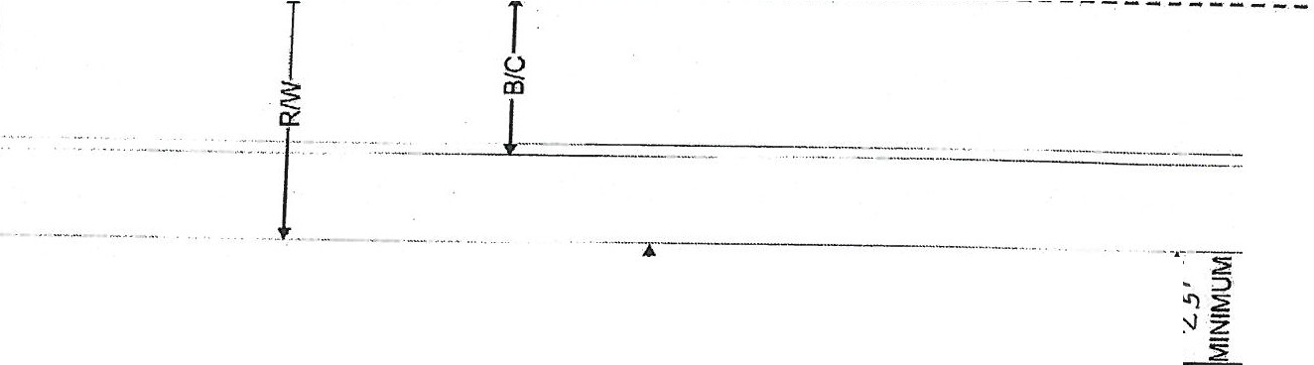
OPTION 1
SE
ff3

OPTION 2
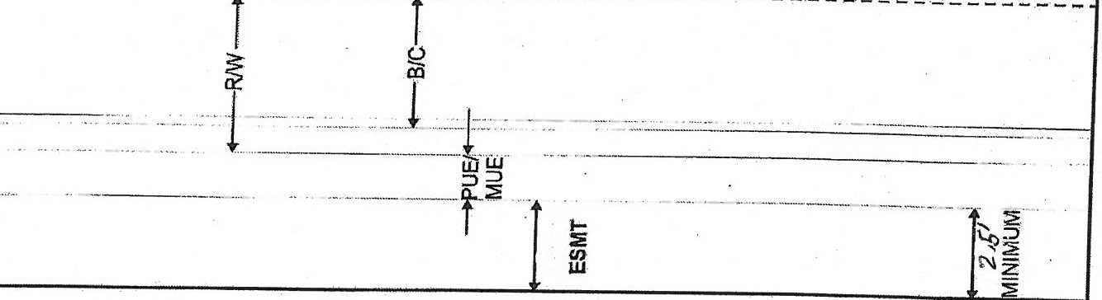

OPTION 3
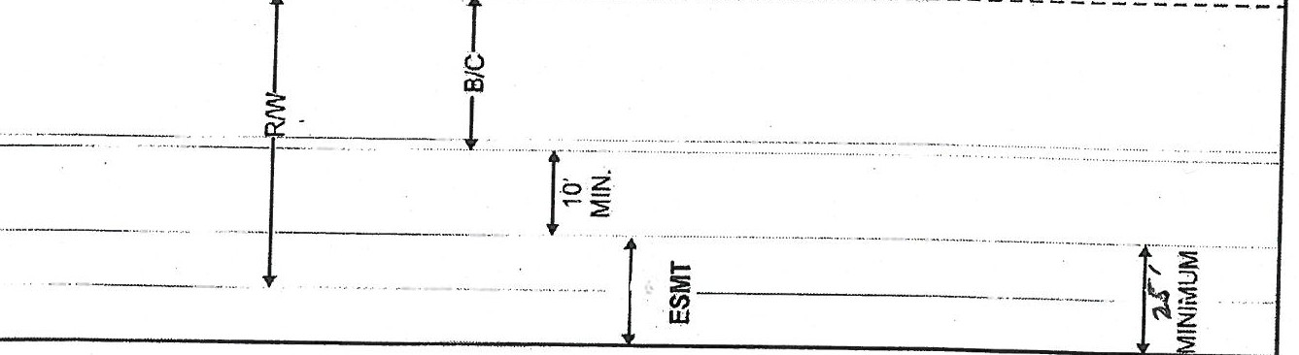
R/IN= Right of Way B/C = Back of Curb PUE/MUE = Public Utility Easement/Municipal Utility Easement

